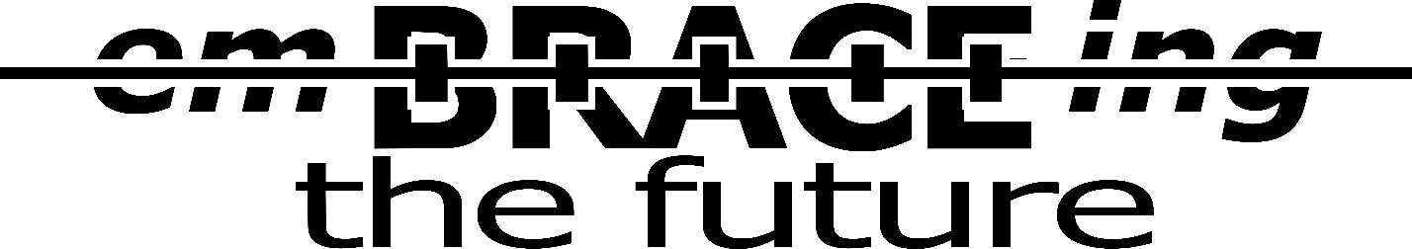

**Unlock the Digital Difference at Parkside Dental**

At Parkside Dental, we're dedicated to making dental care more accessible, affordable, and of the highest quality for everyone. Dr. Alex Broesder is passionate about ensuring that each patient receives precision dental restorations, whether it's a crown, denture, or digitally designed filling (Onlay/Inlay).

**The Power of Our In-House Dental Lab**

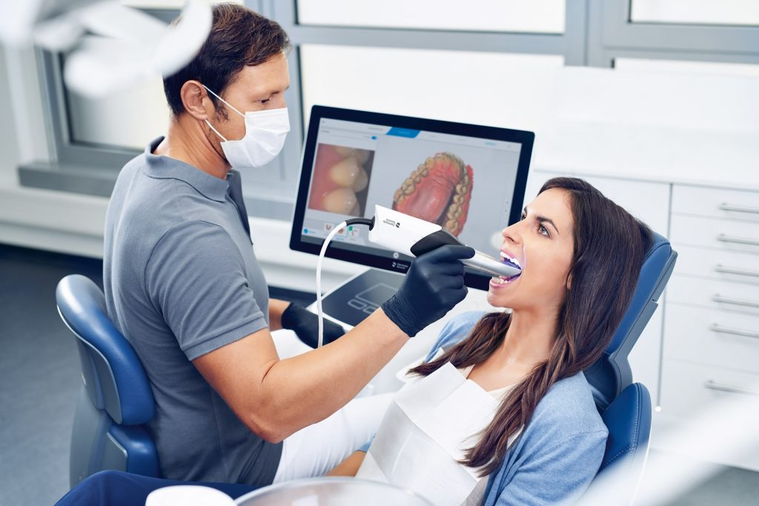Our commitment to excellence led us to establish a fully functional dental lab right here at Parkside Dental. This unique approach sets us apart, enabling us to leverage cutting-edge technology and deliver top-notch dental solutions. Dr. B personally designs your treatment using the latest 3D design software, ensuring you receive the highest quality care.

**What Makes Our Lab Exceptional?**

Unlike many dental offices that advertise "Same-Day" crowns, our full-service, in-house lab spares no expense on equipment. This means you get the same premium material quality you'd expect from a high-end dental lab. However, what truly sets us apart is that your restorations are not designed by a technician but by your trusted family dentist, Dr. Broesder. We aim to eliminate intermediaries to pass on savings to you while maintaining the highest care standards.

**Budget-Friendly Options**

We understand that financial constraints can be a hurdle to optimal dental care. Having an in-house dental lab gives us greater flexibility in offering budget-friendly alternatives. For instance, when a traditional filling or crown is not financially viable, we often suggest Composite/Ceramic Hybrid 3D designed and printed crowns or onlays.

An onlay is essentially an indirect filling, fabricated outside your mouth and then securely cemented in place.

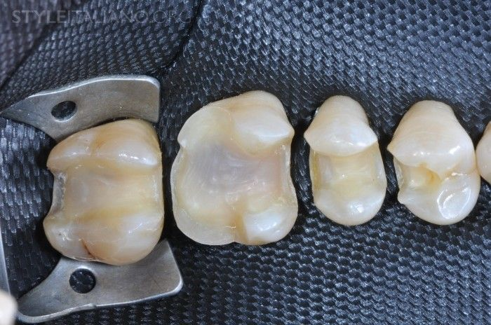 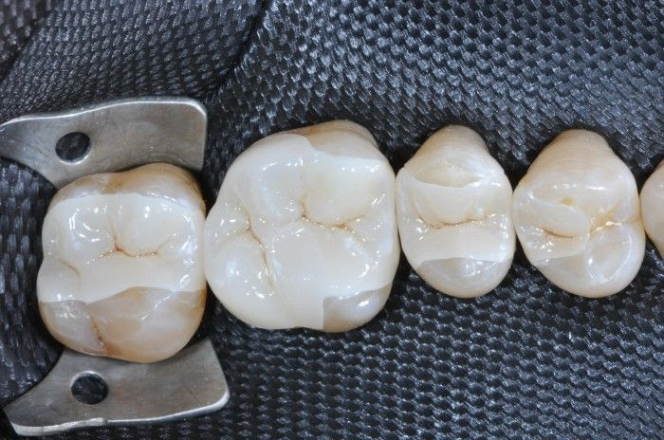

**Why Choose Budget Options?**

While the design and fit quality remain exceptional, budget-friendly options are more affordable because they are quicker to produce. Composite materials are softer and faster to work with compared to harder materials like Zirconia, resulting in faster treatment and cost savings. It's important to note that these composite restorations, while cost-effective, may not provide the same level of strength and longevity as the ideal recommended treatment. While we can't provide warranties for their long-term durability, Dr. Broesder's meticulous design ensures they will outlast teeth without intervention.

**Complete Smile Transformation**

If you require multiple fillings and crowns, our lab can produce over 30 crowns in a single visit. This means your oral health can be completely revitalized in just one visit. Whether you opt for budget or premium products, we offer discounted full mouth reconstruction rates. Additionally, we're expanding our clinic to include a sedation suite, so you can achieve a healthier smile while resting comfortably.

We invite you to experience the digital difference at Parkside Dental, where innovation meets affordability and quality.